|  |  |
| --- | --- |
| *Pacific Gas and Electric Company* | |
| Release 9.7 Installation Guide | |
|  |  |
|  |  |
| Project | ED AM/GIS |
|  |  |
| Prepared by | Rob Rader |
| Date | 8/10/2015 |
| Version | 1.0 |
| Version Type | Draft |

|  |  |  |  |
| --- | --- | --- | --- |
| Revision History | | | |
| Document # | Date | Author | Summary of Changes |
| 1.0 | 8/10/2015 | Rob Rader | Initial Document Creation |
|  |  |  |  |

# Introduction

## Purpose

This document is intended to detail the implementation and configuration steps required to implement Release 9.7.1 Installation Guide. This document describes the various configuration aspects required to complete any manual or automatic patch associated with this release. Each section in this document contains the steps required to patch the system in production.

## Terms Used

|  |  |
| --- | --- |
| OOTB | Out of the box. Unmodified from the commercial version. |
| TFS | Team Foundation Server |

## External Documents

Referenced are any external configuration documents or exports. These are documents that contain more detailed information about configuring a system or documents that can be loaded into an application to perform the configuration detailed in this document.

1. Supporting documentation folder
   1. **TFS documentation location:**

[$/EDAMGIS/Source_Development_10_2_1/Documentation/Data Model/Release Documentation/EDER/9.7.1]($/EDAMGIS/Source_Development_10_2_1/Documentation/Data%20Model/Release%20Documentation/EDER/9.7.1)

## List of Fixes

Below is the list of change requests detailing all fixes for the data model for this release:

|  |  |
| --- | --- |
| **Item Number** | **Title** |
| [23061](http://edappgistfsprd1:8080/tfs/web/wi.aspx?pcguid=15e9a9d1-95cb-4dd0-abfe-5af14ae6201f&id=23061) | Master TFS DM 9.7.1 |
| [23003](http://edappgistfsprd1:8080/tfs/web/wi.aspx?pcguid=15e9a9d1-95cb-4dd0-abfe-5af14ae6201f&id=23003) | PAR 108325: SubsurfaceStructure attribute increase size from string 5 to 25 |
| [23022](http://edappgistfsprd1:8080/tfs/web/wi.aspx?pcguid=15e9a9d1-95cb-4dd0-abfe-5af14ae6201f&id=23022) | Fix the PGE Circuit Color Domain in EDER Maintenance Database |
| [23059](http://edappgistfsprd1:8080/tfs/web/wi.aspx?pcguid=15e9a9d1-95cb-4dd0-abfe-5af14ae6201f&id=23059) | Make the Subtype Field Visible for PriOHConductorInfo |
| [23062](http://edappgistfsprd1:8080/tfs/web/wi.aspx?pcguid=15e9a9d1-95cb-4dd0-abfe-5af14ae6201f&id=23062) | Add GUID based SubsurfaceStructure foreign key field onto VaultPoly |
| [23074](http://edappgistfsprd1:8080/tfs/web/wi.aspx?pcguid=15e9a9d1-95cb-4dd0-abfe-5af14ae6201f&id=23074) | Assign Subtype to Network Protector in ArcCatalog |
| [23095](http://edappgistfsprd1:8080/tfs/web/wi.aspx?pcguid=15e9a9d1-95cb-4dd0-abfe-5af14ae6201f&id=23095) | Assign Measured Length AU to After Feature Split for Feature Classes |
| [23103](http://edappgistfsprd1:8080/tfs/web/wi.aspx?pcguid=15e9a9d1-95cb-4dd0-abfe-5af14ae6201f&id=23103) | DM 9.7.1 Import Fault Indicator Properties |
|  |  |
|  |  |
|  |  |
|  |  |
|  |  |
|  |  |
|  |  |

Contents

1 Introduction 3

1.1 Purpose 3

1.2 Terms Used 3

1.3 External Documents 3

1.4 List of Fixes 4

2 EDGIS 6

2.1 Open a Database Connection in ArcCatalog 6

2.2 20804: Update Temperature Indicator Alias on DuctDef/Duct 7

2.3 21914: Correct 50 Scale Conduit Annotation 8

2.4 22051: Update DUCTPOSITION to conductor info for neutrals 9

2.5 22098: Configure vaults for use by ArcFM Locator 11

2.6 22219: Update 50 Scale Neutral Annotation to use LABELTEXT field 12

2.7 22488: Configure Deactivated LabelText AU on Deactivatable Features 13

2.8 22497: Fault Indicator Field Property Changes 14

2.9 22503: Assign PGE Preserve Anno Angle to DCRectifierAnno Subtype 18

2.10 DM 9.7 Add FEEDERTYPE Field to Schematics Feature Classes 19

2.11 Update Data Model Version Table 20

3 Known Issues 21

# EDGIS

## Open a Database Connection in ArcCatalog

1. Open ArcCatalog.
2. Within the Catalog Tree, expand “Database Connections” and open the active connection for this process. This is the connection that is referenced in the change request associated with this document (<DB name>). If this connection does not exist, create the connection as the EDGIS user and alter the name to the format specified.

## 23003: PAR 108325: SubsurfaceStructure attribute increase size from string 5 to 25

1. Download the zip file attached to the TFS
2. Extract the zip file to under the temp directory on the c drive or d drive.
3. Edit the batch file and replace the following:
   1. Change this line to the correct connection name:

set SCRIPT_GDB_LOCATION=Database Connections\\**lbgisq1q.sde**

* 1. Find the following and replace the password and database:

set SCRIPT_SQL_CONNECTION=edgis/**edgis!Q1Qi@lbgisq1q**

## 23032: Fix the PGE Circuit Color Domain

1. Open ArcCatalog and connect as the EDGIS user to the database to be changed
2. Right click on the connection and choose properties
3. Select the domains tab and select the PGE Circuit Color domain:

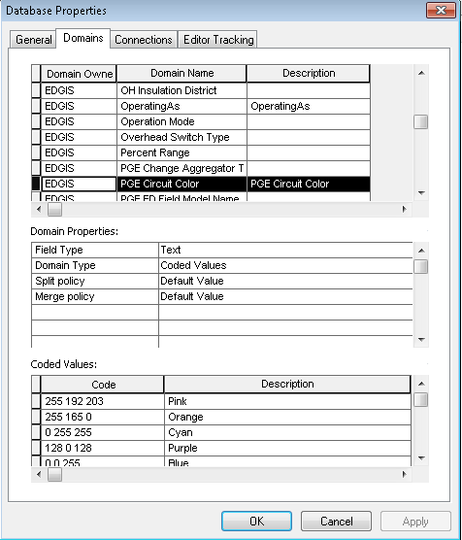

1. Empty out the CODE and Description list by selecting each code one at a time and hitting the delete key, then hit the Apply Button.

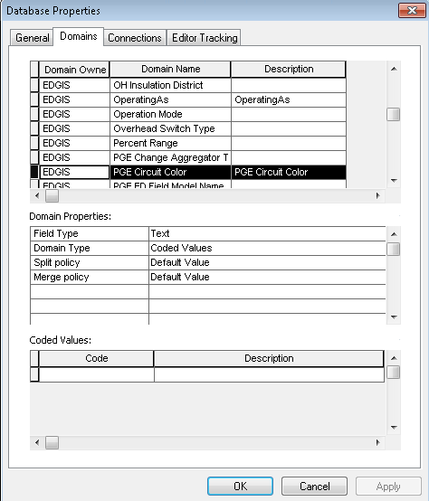

1. Add the following code and description values. The code and description are the same for each:

Blue

Brown

Dark Blue

Dark Pastel Purple

Dark Pastel Red

Ginger Pink

Green

Grey

Light Pastel Green

Light Purple

Lime Green

Orange

Pastel Blue

Pastel Green

Pastel Orange

Pastel Purple

Pastel Red

Pink

Purple

Yellow

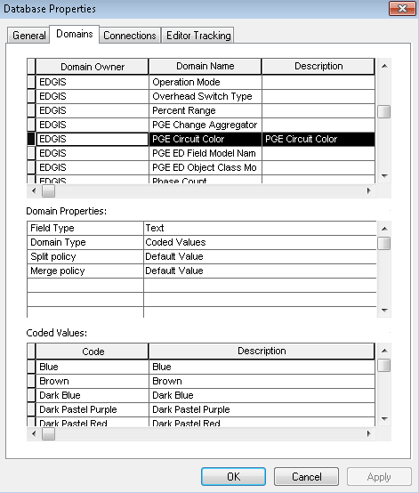

1. After verifying the code and descriptions hit the OK button

## 23059: Make the Subtype Field Visible for PriOHConductorInfo

**Database Configuration:**

1. Open ArcCatalog and connect to the database to change as the EDGIS user.
2. For each of the following tables, do the steps below:

PriOHConductorInfo

PriUGConductorInfo

SecOHConductorInfo

SecUGConductorInfo

1. Right Click on the table and select ArcFM Properties
2. Select the “Field Info” tab
3. Make sure the subtype is set to <All>
4. Choose the field: SUBTYPECD

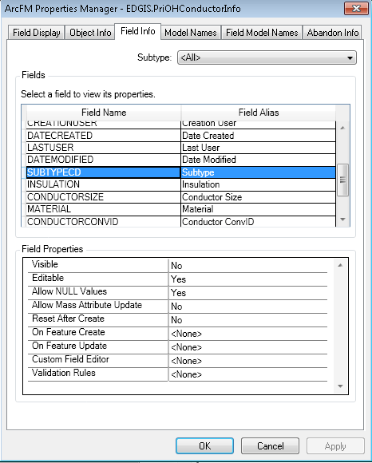

1. Change the visible propertie to YES
2. Click OK

## 23074: Assign Subtype to Network Protector in ArcCatalog

1. Open ArcCatalog and connect to the database to change as the EDGIS user.
2. Select the Network Protector feature class, right click and choose “Properties” (these are the esri not ArcFM poperties).
3. Select the Subtype Tab
4. In the drop down select the SUBTYPECD field

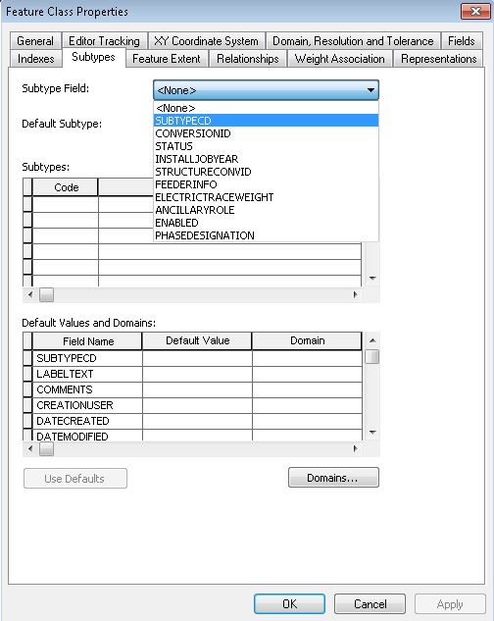

1. Set the code to 1 and Description to Network Protector

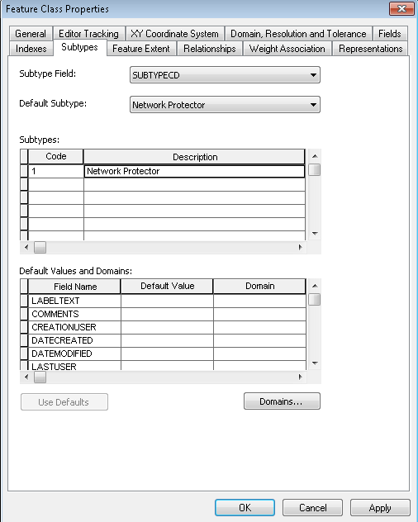

1. Make sure the Default is set to Network Protector and Click OK

## 23095: Assign Measured Length AU to After Feature Split for Feature Classes

1. Open ArcCatalog and connect to the database to change as the EDGIS user.
2. Select the PriOHConductor feature class
3. Right Click on the table and select ArcFM Properties
4. Select the “Object Info” tab
5. Make sure the subtype is set to <All>
6. Choose the field: After Feature Split <Multiple> select the drop down and choose the <Multiple> option to bring up the pop-up box.

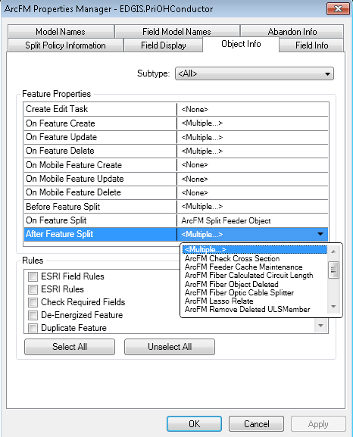

1. In the “ArcFM Assign Auto Updates” dialog select the “PGE Split Measured Length” from the available list

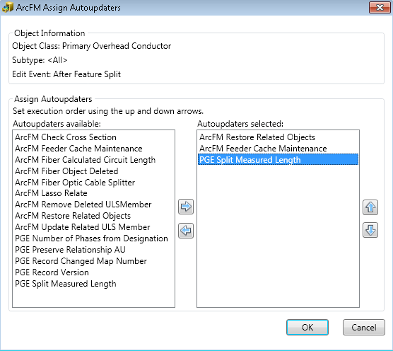

1. Hit the Arrow to move it to the “Autoupdaters selected” list.
2. Click OK
3. Click OK on the main properties dialog to save these settings.

## 23103: DM 9.7.1 Import Fault Indicator Properties

1. Open ArcCatalog and connect to the database to change as the EDGIS user.
2. Select the connection to the database and right click.
3. Select to Import ArcFM Properties.
4. Browse to the file found here:

\\sfetgis-nas01\sfgispoc_data\ApplicationDevelopment\IBM_Delivery\ReleaseInstructions\9.7.1

1. Import with the overwrite option.

## Update Data Model Version Table

**Database Configuration:**

1. Open SQL Plus.
2. Log in using the same server and user as was used in section 2.1.  
     
   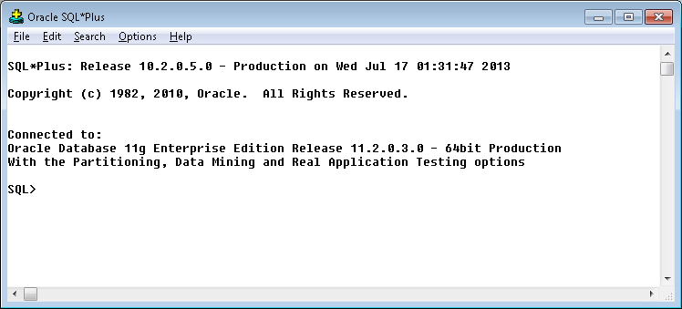
3. Run the SQL below:

update pgedatamodelversion set currentidc='N' where currentidc='Y';

insert into pgedatamodelversion (OBJECTID, CURRENTIDC, DATEAPPLIED, APPLIEDBYPERSONNAME, MODELVERSION) values (**INSERT NEXT VALID ID**,'Y',sysdate,'**<INSERT TEAM MEMBER DONE BY>**','**9.7.1** GOLD **CR<>**');

 commit;

# Known Issues

<Please List any other issues encountered here while following the document>